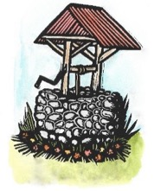
VISIONS
FOR CREATIVE HOUSING SOLUTIONS, INC.

2018 ANNUAL REPORT

The mission of Visions for Creative Housing Solutions, Inc. is to provide residential options, services, and supports designed to meet the needs of adults with special needs.
Visions fosters growth and independence through vocational, social and recreational opportunities at Sunrise Farm, Enfield, NH. Visions is assisting individuals with special needs to lead rich and full lives as productive members of the community.
Financial Snapshot  Gross Revenues rose from $539,000 in 2017 to approximately $705,000 in 2018.  Total expenses rose from $462,000 in 2017 to approximately $585,000 in 2018. | Support & Revenue  Approximately 130 donors contributed over $50,000 in individual contributions during 2018.  Visions would like to thank Granite United Way, the Byrne Foundation, NH Housing Finance Authority and the Grafton County Board of Commissioners for combined grants and donations totaling $96,000.
Our Work  - Provide a safe, attractive living environment  - Focus on private and social space  - Collaborative cooking, preparing healthy meals  - Support with daily living tasks  - Transportation, public and private  - Social opportunities  - Assistance with devising personal goals for each resident  - Support with finding and maintaining employment and volunteer opportunities | Our Philosophy  - Facilitate community opportunities for work, continuing education and social activities  - Sustain long term relationships and friendships  - Provide personal choices  - Offer a permanent residence that provides opportunity for personal growth and independence  - Facilitate an inclusive environment within our community  - Enable our adult children with disabilities to develop a separate life for themselves, making relationships and connections of their own

2018 Highlights |  | 2019 Goals
Visions received a $466,981.00 30-year interest free loan to renovate the three houses at Sunrise Farm.  Visions formed a Lebanon Task Force with families and individuals wanting a Visions’ site in Lebanon.  Visions entered an option to buy property on 12 Green Street. Visions then sought approval through the Zoning Board of the City of Lebanon to open supported housing for individuals with special needs on Green Street.  Visions formed a Capital Campaign Committee to raise funds needed to purchase and renovate the Green Street property.  The development of a tool kit for others to use who are interested in creating supported housing for individuals with developmental disabilities in our area, our state and our country. |  | Visions will obtain a community block grant to purchase property on Green Street for $407,000. At the same time, Visions capital campaign will need to raise the funds needed to renovate the two buildings on Green Street, estimated at $700,000.  The property at Sunrise Farm will be renovated for energy efficiency, including new windows, insulation, appliances, electric solar with battery back-up. A new fire safety system will be installed. Carpeting and paint will be replaced and refreshed as needed.  Develop a Volunteer Program, including hiring a part-time Volunteer Coordinator.  Continue housing forums in New Hampshire to support groups who are interested in starting a non-profit similar to Visions.
The Grafton County Commissioners office dedicated their 2018 Annual Report to David & Sylvia Dow, the founders of Visions, honoring their work in Grafton County supporting individuals with disabilities. |  | 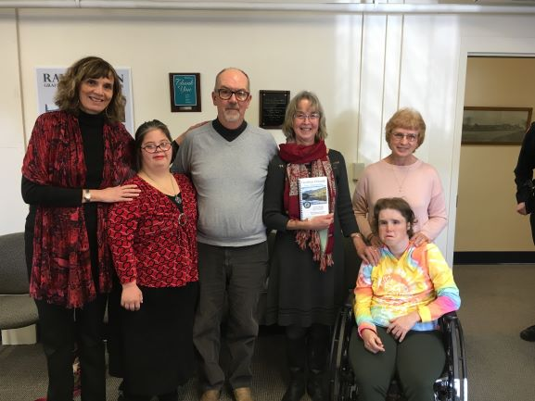
Visions Staff
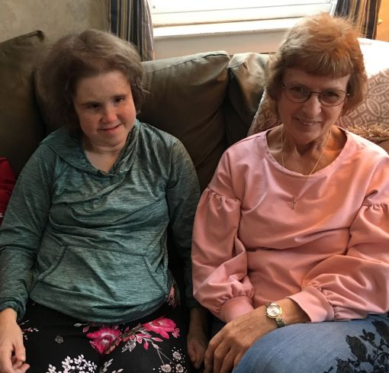 | Visions success is due in large part to the dedication of staff who support our residents with kindness and understanding. Visions staff has grown to 20 full and part-time employees. We have welcomed new staff and appreciate the longevity and commitment of our Visions team.  Betty McKenney is one of our fourteen direct support staff. Betty started with Emma 27 years ago at the Enfield Elementary School. She supported Emma throughout Emma’s school years and into adulthood. Betty continues to work two days a week with Emma, giving her love and support.

Our Residents Giving Back
Our residents love volunteering in the community. In 2018 residents volunteered on a regular basis at the Enfield Police Department, Upper Valley Humane Society, SAU 62, Enfield Town Office, The Haven, The Lebanon Senior Center and the Listen Center. Residents also volunteered at special annual events in the community for Home Town for the Holidays, Caroling, the Shaker 7 Race, and Green Up Day.  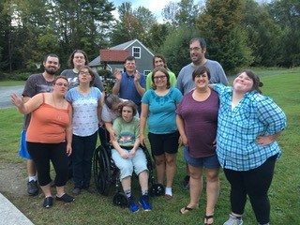 | 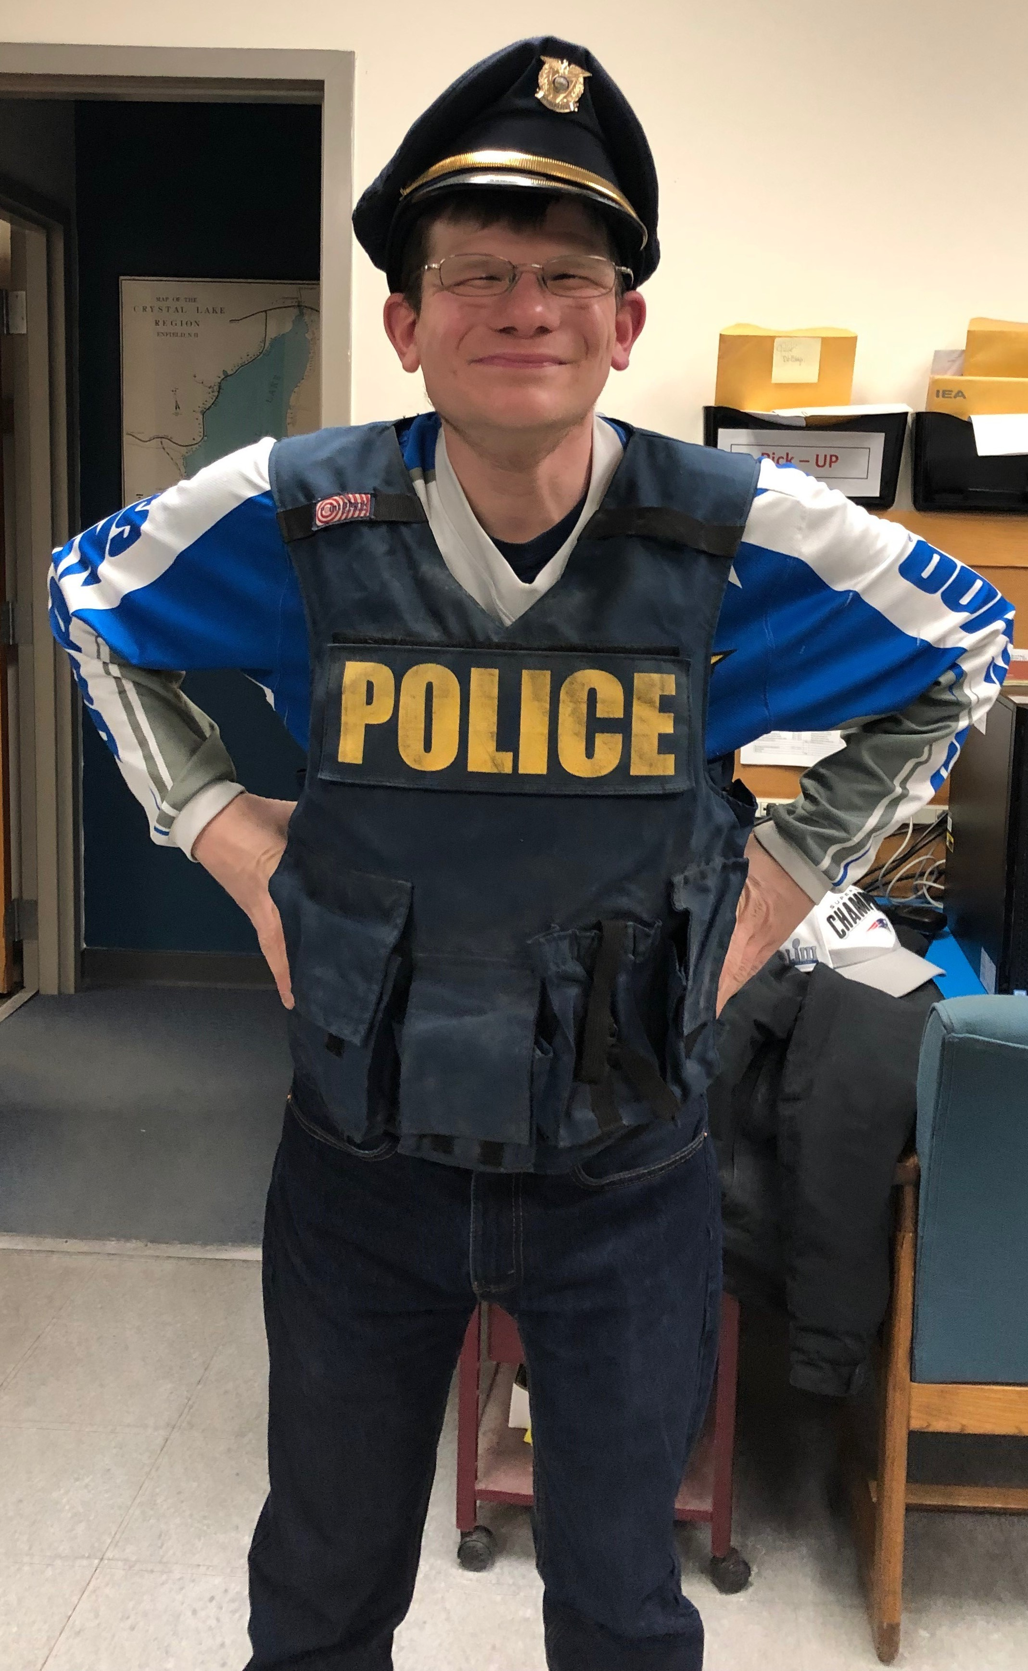  Trevor volunteers weekly at the Enfield  Police Department, making their  cruisers shine.

Visions Volunteers
In 2018 Visions continued to have volunteers come to do a variety of tasks including office work, gardening, crafting, cleaning and organizing. The Volunteers really help Visions shine and sparkle.  We appreciate the many organizations that provide volunteers who come here each year: Cardigan Mountain, Kimball Union Academy, Tuck School of Business, and Hypertherm.  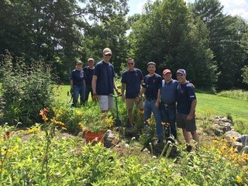 | 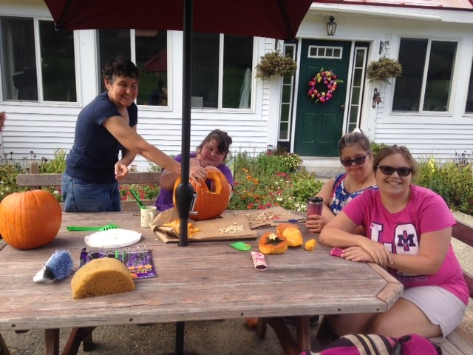  A very special thank you to our volunteer Hilde Baert. Hilde is originally from Belgium and now lives in Lebanon on Green Street. Hilde comes to Visions several days a week to clean and organize and take care of the chickens and ensure that Visions is organized and tidy. Hilde is a prime example of what Volunteers give to Visions, and what they receive in return from our welcoming community. We appreciate Hilde’s warm smile, her sense of humor, dedication and helpful hints!

From a Dad’s Perspective
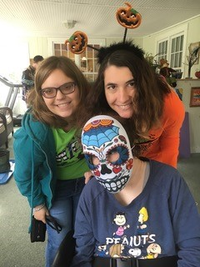 | “We moved to the Upper Valley in November of 2016 concerned about my daughter’s options to be in a supportive environment to foster her independence, build social skills and make critical connections. From the moment we met with the team at Visions we knew we had found a special place where she could flourish, grow and become the person she wanted to be. Vision’s was sensitive to our daughter’s transition (and frankly, ours’ as well!) and really focused on allowing her to be comfortable with her new housemates and the routines associated with her new living arrangement. There are daily “family” meals, group outings, social events and work schedules that are now woven into her new full life allowing her to have connections she seldom had in the past. We are so pleased, as is my daughter, with the environment and the team at Vision’s. It truly provides us great comfort to know she is happy and being the person she wants to be.”
This is our Visions 2020

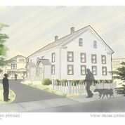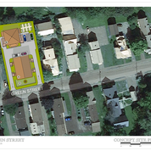
We have been inundated by individuals and groups who want to have the type of support that Visions offers: comprehensive wrap-around services including community, residential, employment and overall well-being and health for our residents.

Currently Visions has an option to purchase property on 12 Green Street in Lebanon, New Hampshire. Visions is currently working with architects and consultants to plan for renovation, and purchasing the property with a combination of grants, loans and starting a capital campaign that will kick off in May 2019.

Green Street will support 10 full time residents with the same supported housing model used at Sunrise Farm.

Our hope is that the community will support our next endeavor in Lebanon on 12 Green Street. We thank you for your support.

Thank you to our Donors and Supporters!

Corporate Donors and Foundations  Atlassian, Inc  Byrne Foundation  Canaan Hardware  King Arthur Flour  Martin’s Mechanical  Valley Turf Services | Grants  Grafton County Board of Commissioners  Granite United Way  Ledyard National Bank  Mascoma Savings Bank  NH Housing Finance Authority  Sustaining Member  Nancy Smith
2018 Visions Board of Directors  Carol Andrew, President  Lyndsay Porreca, Vice President  Fred Williamson, Treasurer  Elizabeth Larsen, Secretary | Board Members at Large  Adam Ricker  Lori Meyers  Scott Gilmore  Rich Casano  Terry Dorr
Supporting Agencies
Pathways of the Upper Valley

Ways to Give

VISIONS is a 501c3. All gifts are fully deductible according to IRS regulations.

- Give a charitable gift of CASH or write a CHECK
- Give APPRECIATED SECURITIES – instruct your broker to give shares of appreciated stock to Visions’ campaign
- IRA CHARITABLE TRANSFER – if you are 70 ½ years of age or older, instruct your IRA financial institution to make a gift to Visions (a total of $100,000 to one or various charities in a fiscal year)
- IN-KIND gift, meaning you give real property, such as new kitchen equipment, new
Furniture, etc.

In 2017 we had our first sustaining member supporting our mission. If you are interested in becoming a sustaining member with a monthly contribution to Visions to help support our operating costs, please contact us.

Visions for Creative Housing Solutions, Inc.
Sylvia Dow, Executive Director
8 Sunrise Farm Lane
Enfield, NH. 03748
603-632-7707
vfchsorg@gmail.com
www.visionsnh.org

Thank you to our 2018 donors!
We extend our gratitude to the donors and sponsors
whose contributions are invaluable to Visions.

We apologize for any names that may have been inadvertently omitted.
*Includes support received 1/1/18 through 12/31/18.

Rosemary Affeldt | Lauren Glaser | James & Susan Moretti
Carol & Wallace Andrews | Michael Glaser | Richard & Elizabeth Morse
Prudence Arndt | Steven & Roni Glaser | William & Nancy Murphy
Constance Bardorf | Kenneth Gough | Lori Meyers
Richard Bates | Michael & Susan Gray | Emmett & Helen Norton
Gabrielle Black | Lisa Green | Frederick & Cynthia O'Brien
William Black | Katrina Hansen | Joseph & Ellen O'Brien
Pete & Ruth Bleyler | Tim & Sally Hebert | Francis & Joanne Oscadal
Margaret Bragg | June Hemberger | Patricia Pearce
Mary Brenning | Leslie Holland | Susan Perry
Nicholas Bresette | Doreen Holmes | Jane Plumley
Thomas VG Brown | Tom & Elizabeth Horner | Phyliss & Louis Polonkay
Dorothy Byrne | Gerald & Jane Huppee | Christopher Reed
Deborah Cantlin | Elizabeth & Frank Johns | Allyn & Charlene Ricker
Carol Carr | Anne Johnson | Nickolas & Mary Anne Sarbanis
Theron & Deborah Chase | Jennifer Johnson | Mark & Ellen Schwartz
Becky Clancy | Meredith Johnson | Mark & Nancy Seavers
William Cooley | Barbara Klocek | Gary & Karen Shepard
Carolyn Cusick | John Kluge | Lindsay Smith
Robert & Susan DeLuca | William & Marilyn Knight | Meredith Smith
Lisa (Stripe) Demarest | Robert & Deborah LaCroix | Nancy Smith
George Dorr III | Elizabeth Larsen | Arlen Spacciante
David & Sylvia Dow | Sharon Lewis | J. Pepe Spacciante
Deborah Ann Dow | John & Teresa Lyons | Elizabeth St. Amand
Carol Dozibrin | James & Marjorie Matthews | Adrienne Stark
Sarah Elliott | Tucker McCarthy | Dolores Struckhoff
Catherine & David Farnsworth | Elizabeth McCormack | Danielle Thompson
Bonnie Fields | James McInnes | Jo Anne Unruh
Pamela Fitzgerald | Peter & Jane McLaughlin | Nancy Walters
Thomas & Jennifer Frederick | Andy & Susan Mellow | Holly West
Ashley Gibson | Linda Meltzer | Jacqueline Williamson
Samuel Gilmore | Robert Michenfelder | Karen Wolk
Scott Gilmore | Vicky & Francis Moran

Thank you to all our supporters and donors through Facebook!

